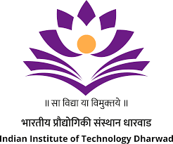
NATIONAL SYMPOSIUM ON ‘SMART INTERFACES: COLLOIDS IN MEDICINE, ENERGY, AND MATERIALS’
OCTOBER 9-10, 2025
IIT DHARWAD, KARNATAKA-580011, INDIA

The Department of Chemical Engineering, IIT Dharwad, Karnataka, India hosted a two-day National Symposium on “Smart Interfaces: Colloids in Medicine, Energy, and Materials” sponsored by the Anusandhan National Research Foundation (ANRF) in offline mode from October 9-10, 2025. The symposium served as a vibrant platform for researchers, scientists, engineers, and academicians to share cutting-edge developments and exchange transformative ideas in the field of colloid and interface science, with a strong focus on their applications in medicine, sustainable energy, and advanced materials. The shared knowledge is aimed to contribute to our economic prosperity and elevate the quality of life for all members of society.

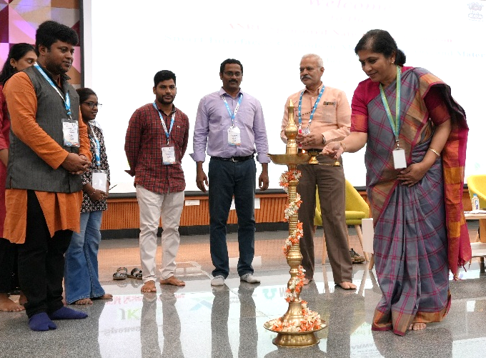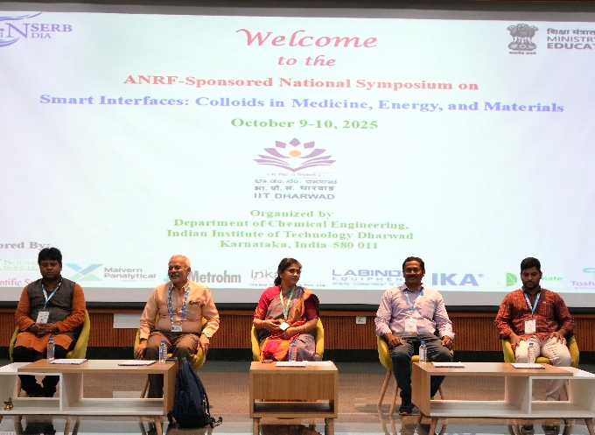
Photograph taken during the inaugural program of ANRF Sponsored Synposium on 09th October 2025

The two-day program took place in the Central Learning theatre (F 500+) auditorium of IIT Dharwad. The program was inaugurated by the Chief Guest Dr. Sridevi Khambampathy, CEO, Shilpa Biologicals, Dharwad, Karnataka and delivered an inspiring address highlighting the significance of interdisciplinary collaboration in driving innovation across biomedical engineering, pharmaceuticals, energy systems, and advanced materials. She emphasized the importance of translating research from the laboratory to real-world applications, and the need for strategic partnerships among academia, industry, and government to accelerate impactful technological advancements. The event was patroned by Prof. VenkappayyA R dEsAi, honorable Director, IIT Dharwad. He emphasized the importance of interdisciplinary collaboration and innovation-driven research that addresses real-world challenges and highlighted that the symposium serve as a valuable platform for knowledge exchange, networking, and inspiring young researchers to pursue impactful science. The event was graced by the presence of Deans, faculty colleagues, students, and research scholars of IIT Dharwad, and participants from other Institutes across India.

The Convener Prof. C. Ravikumar of the symposium from the Chemical Engineering Department delivered the introductory address. He outlined the symposium’s purpose and objectives, introduced the speakers and session chairs, and provided details about the sponsors and the event's schedule. Prof. Suvamay Jana (Head of the Chemical Engineering Dept.) briefly presented their respective Departments. The Co-Convener Prof. Ashok Kumar Ummireddi extended gratitude through a vote of thanks.

A total of 13 invited lectures were delivered by distinguished Professors and Scientists at the symposium, including Prof. Guruswamy Kumaraswamy (IIT Bombay), Prof. Rabibrata Mukherjee (IIT Kharagpur), Prof. Madivala G. Basavaraj (IIT Madras), Prof. Ethayaraja Mani (IIT Madras), Dr.Vishal Dhavale (CSIR-CECRI Madras Unit), Prof. Nirmalya Bachhar (IISc Bangalore), Prof. Sri Sivakumar (IIT Kanpur), Prof. Swati Sudhakar (IIT Madras), Prof. Rochish M. Thaokar (IIT Bombay), Prof. Pramod P. Pillai (IISER Pune), Prof. Santosh Kumar Meena (IIT Ropar), Prof. Kailas L. Wasewar (VNIT Nagpur), Prof. Siddhartha Panda (IIT Kanpur).

A total of 105 participants from various institutions like K.S.R College of Engineering, Tamil Nadu; Rani Channamma University, Belagavi, Karnataka; Mahesh Institute of Engineering and Technology, Ashti, Beed District, Maharashtra; A.G.M. Rural College of Engineering and Technology, Varur, Karnataka; Soniya Education Trust’s College of Pharmacy, Dharwad, Karnataka; Visvesvaraya National Institute of Technology (VNIT), Nagpur, Maharashtra; Siddaganga Institute of Technology, Tumkur, Karnataka; Karnataka University, Dharwad, Karnataka; DIMHANS, Dharwad, Karnataka; Shri Gavisiddeshwar Arts, Science and Commerce College, Koppal, Karnataka; Soniya Education Trust College, Dharwad, Karnataka; S.E.T’s College of Pharmacy, Dharwad, Karnataka; KLE Technological University, Dr. M.S. Sheshgiri Campus, Belagavi, Karnataka; KLE Technological University, Belagavi Campus, Karnataka; SKE Society’s Govindram Seksaria Science College (Autonomous), Belagavi, Karnataka; PSG College of Technology & PSG Institute of Advanced Studies, Coimbatore, Tamil Nadu; Smt. A.S.M. College for Women, Ballari, Karnataka; Bapuji Institute of Engineering and Technology, Davangere, Karnataka; KLE Dr. M.S. Sheshgiri Campus, Belagavi, Karnataka; KLE Engineering College, Belagavi, Karnataka; Government Degree College, Yadgir, Karnataka; Karnatak Science College, Dharwad, Karnataka have participated in the symposium.

All the participants and invited speakers received a registration kit, which comprised a bag, a symposim proceedings, a writing pad and pen, and an Institute newsletter. Additionally, all attendees, including both participants and delegates were catered to with breakfast, lunch and refreshments throughout the entire two-day duration of the event.

The poster presentations for all the participants were held in the auditorium hall of the institute. A total of 35 presentations were made, and 3 best poster awards were given. Mrs.Charushila V. Balikai from SKES’s GSS College Belagavi secured first best poster award, Dr. Vidya Raj from PSG College of Technology Coimbatore, PSG Institute of Advanced Studies, Coimbatore and Ms. Keerthana Devi P from Siddaganaga Institute of Technology secured second best poster award, and Ms. Akshata from Karnatak University Dharwad and Mr. Guruprasad Bonageri from Rani Channamma University secured third best poster award respectively.
The event was sponsored by various organizations, including ANRF (New Delhi); PSM Scientifics (Hubli); Aimil-Malvern Panalytical (New Delhi); Inkarp (Bengaluru); Metrohm (Bengaluru); JK Scientific Solutions (Dharwad); Toshniwal Brothers (Bengaluru); Labmate (Bengaluru); IKA (Bengaluru); LabIndia Equipments (Bengaluru).

Further, the successful execution and seamless conduct of the symposium were made possible with the valuable assistance of Ph.D. scholars from the Department of Chemical Engineering, namely Mahima Ganguly, Manohar Jammula, Shanly Shajan, Laxmi Priya Swain, Nidigonda Kiranmai, Priyambika Mohanty, Santhosh Kumar P, Vidhi; and non-teaching Staff members Anitha Verma, Bharath G. Relekar, Rahul Somvanshi, Varun Meda. Their contributions were instrumental in ensuring the symposium’s success.

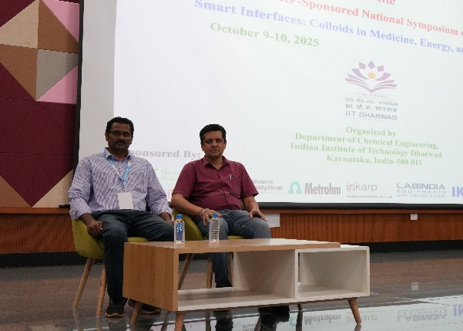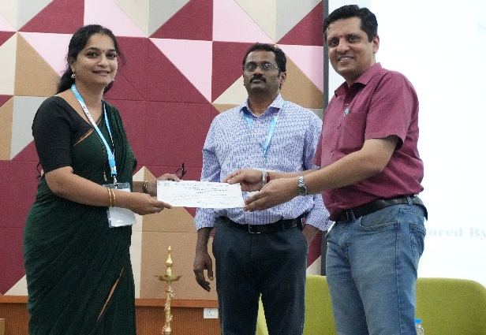
Photograph taken during the valedictory function of the symposium October 10, 2025

The valedictory function took place in the presence of the Chief Guests Prof. Dileep A.D.,
Dean (Administration) of IIT Dharwad. During this ceremony, all the participants were rewarded with a participation certificate. Prof. C. Ravikumar delivered the vote of thanks.

Sincerely,
Prof. C. Ravikumar, and Prof. Ashok Kumar Ummireddi Conveners


ANRF Sponsored National Symposium
on
‘Smart Interfaces: Colloids in Medicine, Energy, and Materials’

Department of Chemical Engineering, IIT Dharwad, Karnataka, India-580011
October 9-10, 2025

Program Schedule

Venue: Auditorium, F 500+, Central Learning Theatre, IIT Dharwad

Time |  | Events
Day-1 Thursday 9th October 2025
08.15 - 9.45 am |  | Registration and Breakfast
09.45 - 10.15 am |  | Inauguration function  Chief Guest: Dr. Sridevi Khambhampaty, CEO, Shilpa Biologicals Pvt. Ltd, Dharwad  Patron: Prof. VenkappayyA R. dEsAi, Director, IIT Dharwad
10.15 - 10.45 am |  | High Tea
Session Chair: Prof. Nirmalya Bachhar
10.45 - 11.30 am |  | Lecture 1: Prof. Sri Sivakumar, Dept. of Chemical Engg., IIT Kanpur  Title: Designing Nanomaterials for Targeted Drug Delivery and Organ-on-a-Chip Systems
11.30 am - 12.15 pm |  | Lecture 2: Prof. Siddhartha Panda, Dept. of Chemical Engg., IIT Kanpur  Title: Flexible Printed Gas Sensors - Sensing Mechanisms and Applications
12.15 - 1.00 pm |  | Lecture 3: Prof. Pramod P. Pillai, Dept. of Chemistry, IISER Pune  Title: Solar Energy Utilization with 'Hot Charges' and 'Hot Surfaces'
01.00 - 03.30 pm |  | Lunch Break  Poster Session-1 (Auditorium)

Session Chair: Prof. Pramod P. Pillai

03.30 - 04.15 pm |  | Lecture 4: Prof. Santosh Kumar Meena, Dept. of Chemical Engg., IIT Ropar  Title: Rational Design of Nanoparticles for Sensing, Biomedical, and Environmental Applications via Molecular Simulations
04.15 - 04.30 pm |  | Coffee Break
04.30 - 05.15 pm |  | Lecture 5: Prof. Nirmalya Bachhar, Dept. of Chemical Engg., IISc Bangalore  Title: Understanding the Effect of Alkylation on Drug Design, Transport, and Aggregation
05.15 – 06.00 pm |  | Lecture 6: Dr. Vishal M. Dhavale, CSIR-CECRI Madras  Title: Electrocatalyst and Electrolyte Engineering for Energy Applications
Day-2 Friday 10th October 2025
08.15 - 9.30 am | Breakfast
Session Chair: Prof. Swati Sudhakar

09.30 - 10.15 am |  | Lecture 7: Prof. Guruswamy Kumaraswamy, Dept. of Chemical Engg., IIT Bombay  Title: Model Systems by Covalently Coupling Colloids: Strings and Sheets
10.15 - 11.00 am |  | Lecture 8: Prof. Rochish M. Thaokar, Dept. of Chemical Engg., IIT Bombay  Title: Electroporation for Anti-Cancer Treatment: Understanding Multiphysics Using Giant Vesicles as Biomimetic System
11.00 - 11.15 am |  | Coffee Break
11.15 am - 12.00 pm |  | Lecture 9: Prof. Rabibrata Mukherjee, Dept. of Chemical Engg., IIT Kharagpur  Title: Instability, Dynamics and Ordering in Ultrathin Polymer Thin Films
12.00 - 12.45 pm |  | Lecture 10: Prof. Ethayaraja Mani, Dept. of Chemical Engg., IIT Madras  Title: Inertial Effect on the Laning Transition in Driven Colloids
12.45 - 3.30 pm |  | Lunch Break  Poster Session-2 (Auditorium)
Session Chair: Prof. Ethayaraja Mani

03.30 - 4.15 pm |  | Lecture 11: Prof. Swati Sudhakar, Dept. of Applied Mechanics & Biomedical Engg., IIT Madras  Title: Unveiling Cellular Nanotherapeutic Dynamics: Molecular Insights and Mechanisms
04.15 - 04.30 pm |  | Coffee Break
04.30 - 5.15 pm |  | Lecture 12: Prof. Madivala G. Basavaraj, Dept. of Chemical Engg., IIT Madras  Title: Interfacial Engineering of Colloids for Pharmaceutical and Agricultural Applications
05.15 - 6.00 pm |  | Lecture 13: Prof. Kailas L. Wasewar, Dept. of Chemical Engg., VNIT Nagpur  Title: Process Intensification of Liq.-Liq. Extraction using Smart Interfaces
06.00 - 6.30 pm |  | Valedictory Function  Chief Guest: PROF. Dileep A.D., Dean (Administration), IIT Dharwad  (Feedback Discussion and Certificate Distribution)

